**CI/CD PIPELINE FOR SDLC**

**SDLC’s Problems without CI/CD pipeline:**

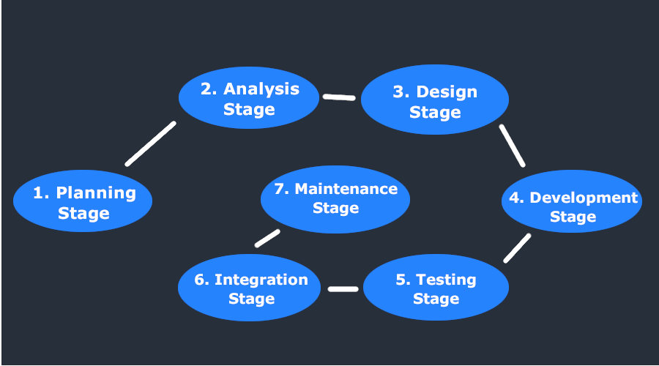

1. Not scalable
2. No automation
3. Against of the philosophy of Rapid development
4. No backtracking
5. For a same update System Admin has to face a lot of problems and many more

**Solutions of CI/CD pipeline:**

Ansible

Github

Developer

Testing

Jenkins

Docker

Production

kubernetes

Fig: Solutions of CI/CD

**Let’s talk about the brief of my project:**

**Prerequisites:**

**Main Tools:**

   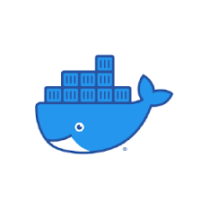 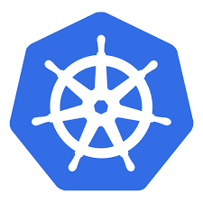 

**Sub Tools:**

** or** 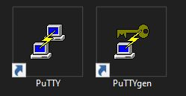



**=> 3 AWS(EC2 server)**

i) server1(ubuntu-t2.micro) for Jenkins

ii) server2(ubuntu-t2.micro) for Ansible

iii) server3(ubuntu-t2.medium) for Kubernetes

*Dashboard of EC2:

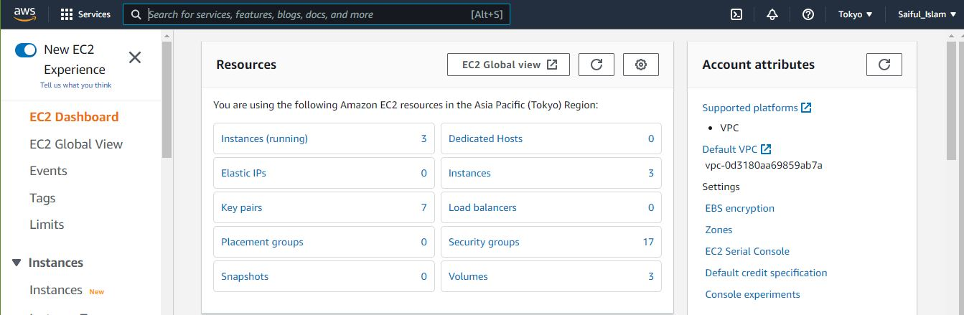

*Running Required 3 Instances:

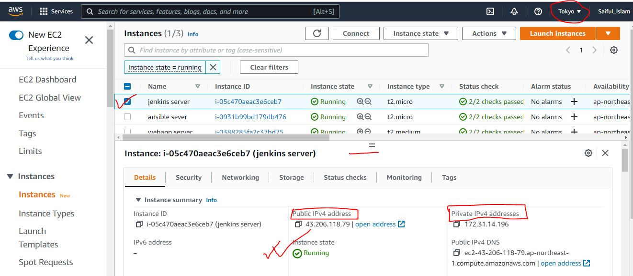

To access the command prompt of instance through the PUTTY:

1. Putty key generation (dot pem file to dot ppk file) 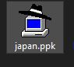
2. Public key of the targeted instance

*Command prompt after applying the above steps:

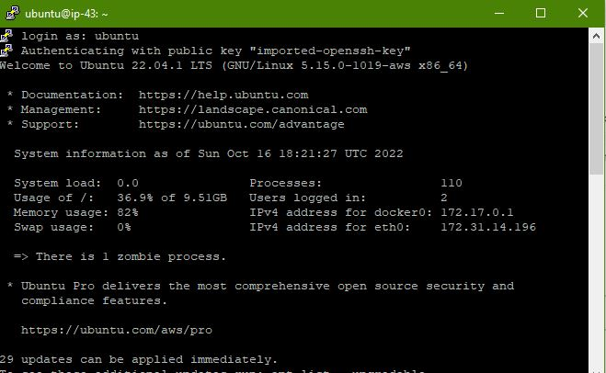

**Targeted Github Repo:**

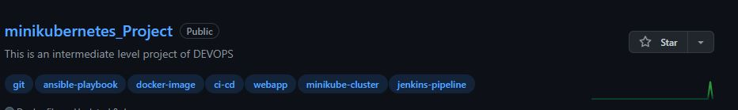

Important files of the Repo:

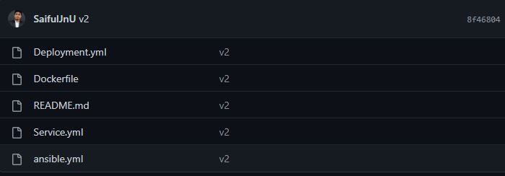

Dockerfile

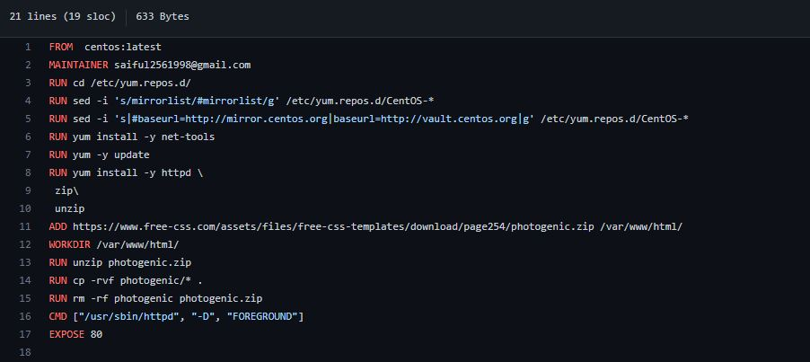

**Jenkins (Step1):**

After installing the Jenkins in command PUTTY command prompt using Jenkins(ec2 server) we can have the following Jenkins(online server): public ip:8080

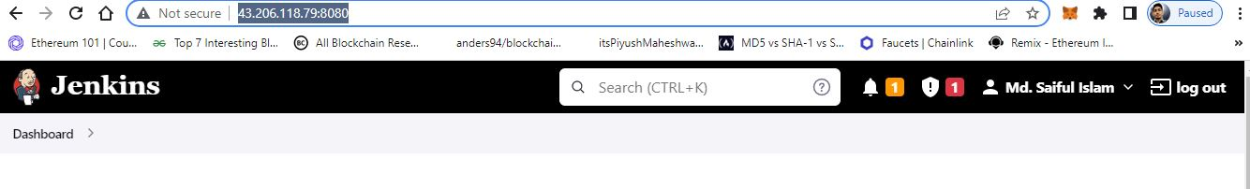

**Jenkins Dashboard:**

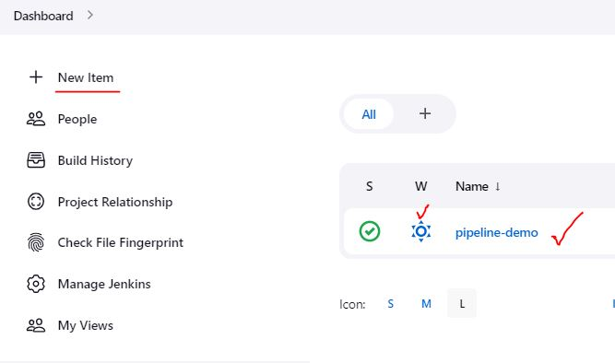

**Github Configuration:**

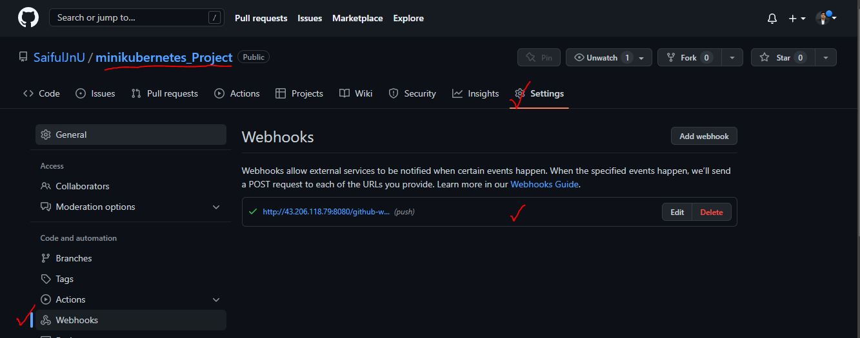

**Jenkins (Step2):**

After creating new item(project) then selecting basic stuffs then pipeline scripting:

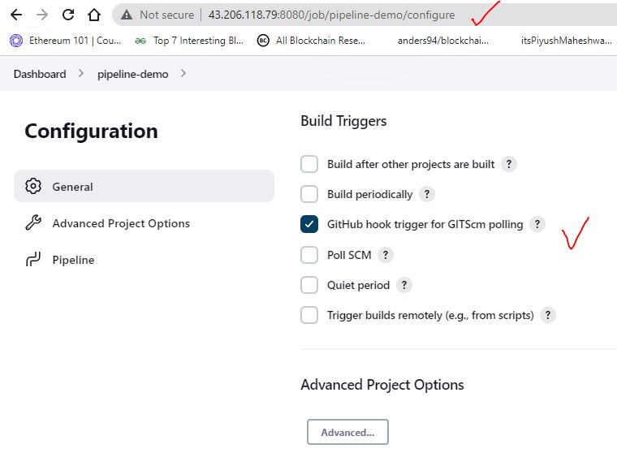

**Scripting for all stages:**

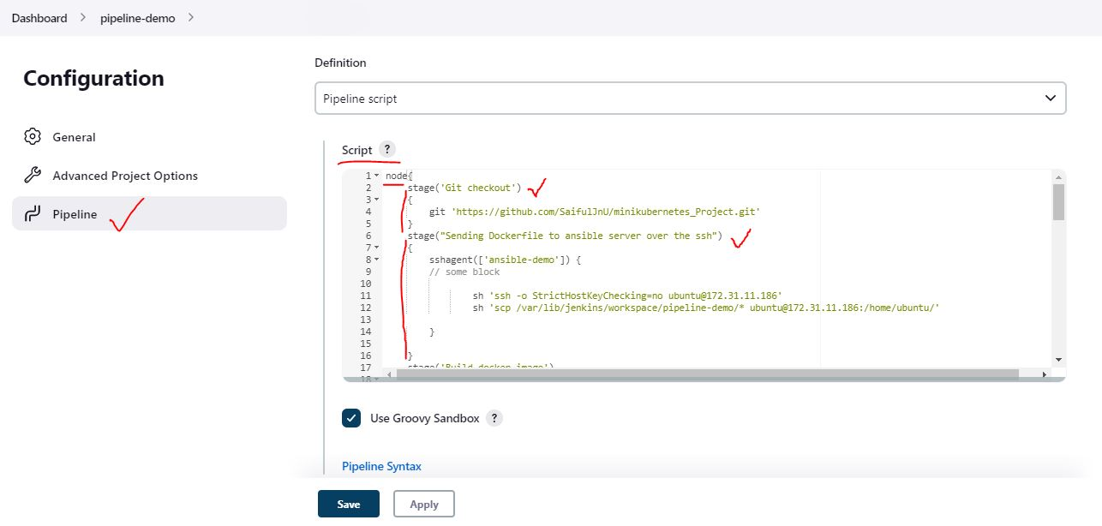

**Jenkins (Step3):**

Now time to build and run. After building and running:

Console Output:

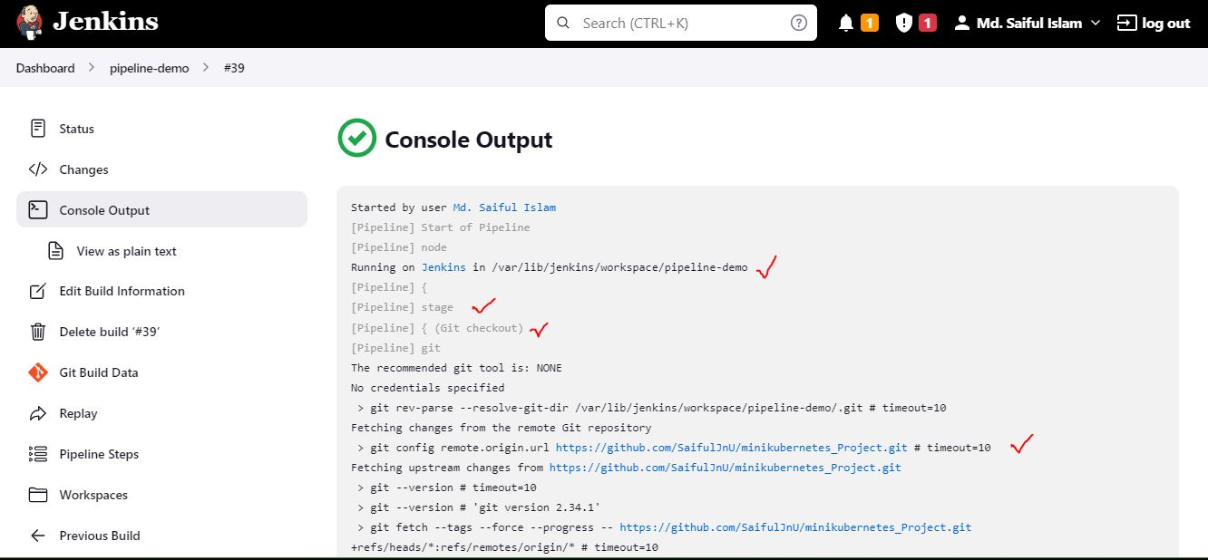

Success:

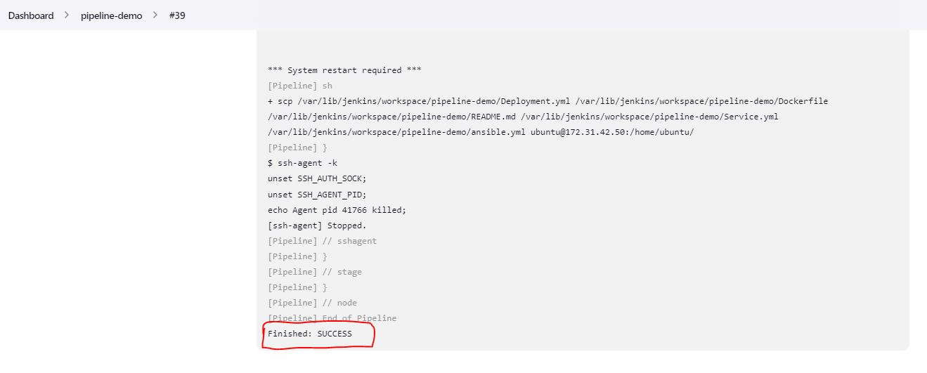

**Full Pipeline staging:**

After setup all servers(Jenkins, Ansible, Kubernetes) and scripting for all servers:

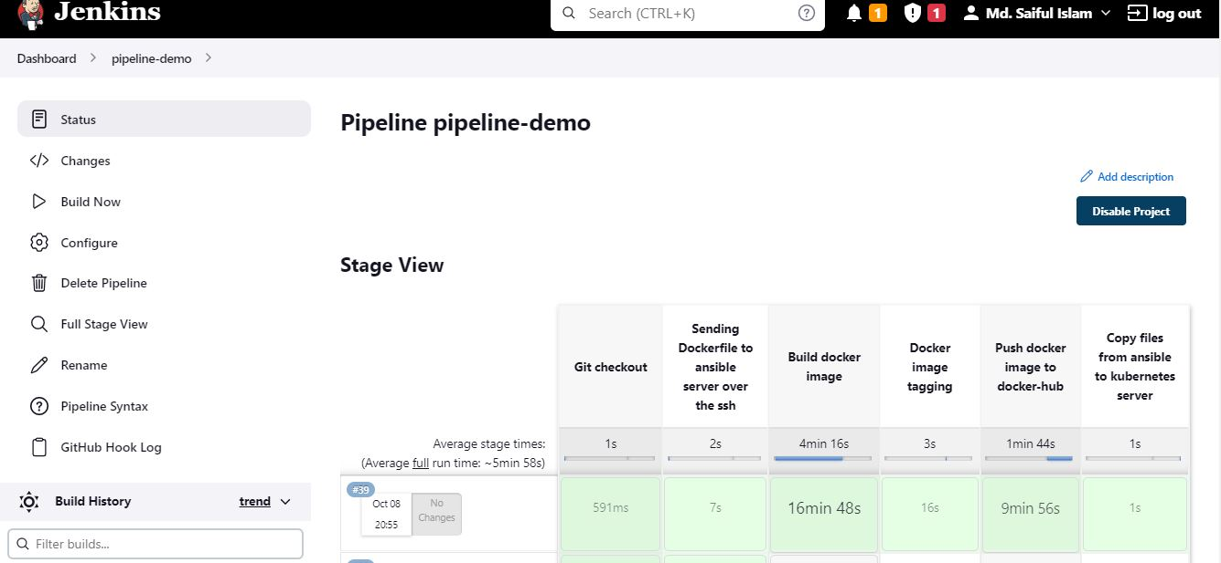

**Note: for every build docker must has to be logged in, using the ansible terminal.**

**DockerHub:**

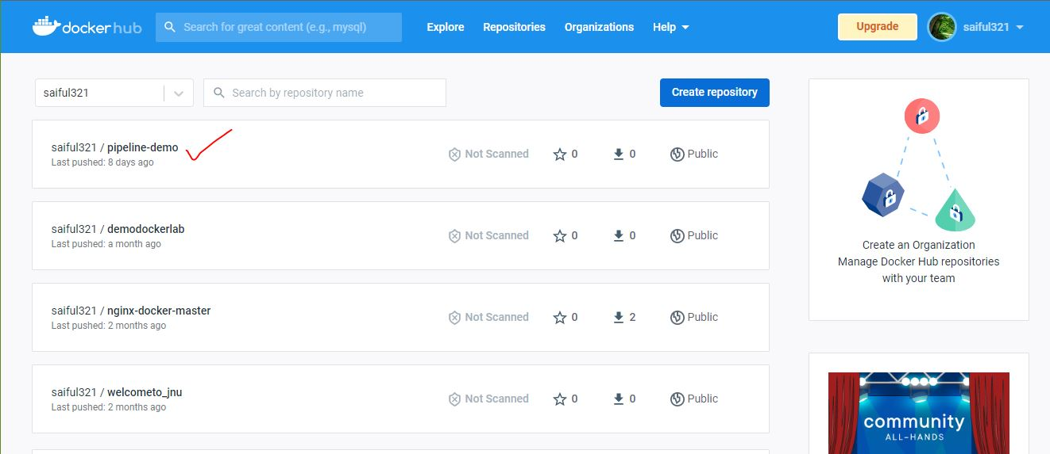

Updated version:

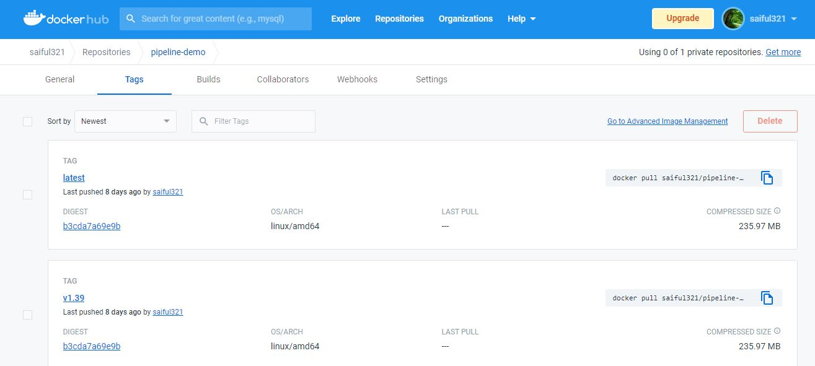

**Awesome, now time to live demonstration…**

***Link1*:**

[***https://apnortheast1.console.aws.amazon.com/ec2/home?region=ap-northeast-1#Instances:instanceState=running***](https://apnortheast1.console.aws.amazon.com/ec2/home?region=ap-northeast-1#Instances:instanceState=running)

***Link2:***

[***https://hub.docker.com/repository/docker/saiful321/pipeline-demo***](https://hub.docker.com/repository/docker/saiful321/pipeline-demo)

***Link3:***

[***https://github.com/SaifulJnU/minikubernetes_Project***](https://github.com/SaifulJnU/minikubernetes_Project)

***Link4:***

[***http://43.206.118.79:8080/***](http://43.206.118.79:8080/)